AO Technical Specifications

Created by Soundra

# Brief Summary:

Answer-On is a management tool for performing Call Center Agent Retention Predictive analysis. The AO Extract code-set is a sub-system of the Answer-On effort. The Extract has 2 jobs, namely, Input File and Extract File. Input file runs every 16th of the month. Extract file runs after that based on availability of the Match File. The AO Extract connects only to the ACD system. There is no Maxdat database objects for this effort.

# Additional Documents:

Documents generated/used during the initial development phase are under [svn://rcmxapp1d.maximus.com/maxdat/ContactCenter/trunk/kettle/AO/docs/Initial Docs](svn://rcmxapp1d.maximus.com/maxdat/ContactCenter/trunk/kettle/AO/docs/Initial%20Docs).

# Source Code:

|  |  |
| --- | --- |
| SVN link | Comment |
| [svn://rcmxapp1d.maximus.com/maxdat/ContactCenter/trunk/kettle/AO](svn://rcmxapp1d.maximus.com/maxdat/ContactCenter/trunk/kettle/AO/docs/Initial%20Docs) | AO Project Dirctory |
| <svn://rcmxapp1d.maximus.com/maxdat/ContactCenter/trunk/kettle/AO/main> | Main Source code Dir |
| <svn://rcmxapp1d.maximus.com/maxdat/ContactCenter/trunk/kettle/AO/main/bin> | Executable shell files |
| <svn://rcmxapp1d.maximus.com/maxdat/ContactCenter/trunk/kettle/AO/main/conf> | Consists of the Properties file for each Project. The property values are specific for each Project. |
| <svn://rcmxapp1d.maximus.com/maxdat/ContactCenter/trunk/kettle/AO/main/jobs> | .KJBs dir |
| <svn://rcmxapp1d.maximus.com/maxdat/ContactCenter/trunk/kettle/AO/main/transforms> | .KTR dir |
|  |  |

# Main Source code Files:

|  |  |
| --- | --- |
| Filename | Comment |
| run_ao_input_jobs.sh | Shell file to run the Input file generation step |
| run_ao_extract_jobs.sh | Shell file to run the Extract file generation step |
| manage_agent_input_extracts.kjb | Job to run Input file generation for all Projects that have a properties file in “conf” dir |
| manage_all_acd_extracts.kjb | Job to run Extract file generation for all Projects that have a properties file in “conf” dir |

# Initial Source code deployment jira:

CiscoEnterprise CC PRD deployment - <https://defect-tracker.maximus.com/browse/MAXDAT-3906>

TX Prod deployment - <https://jira.maximus.com/browse/TXEB-8046>

# Sample Job Emails:

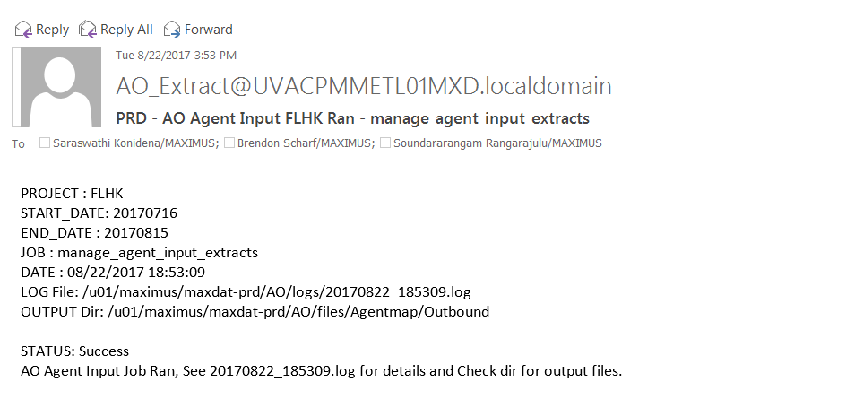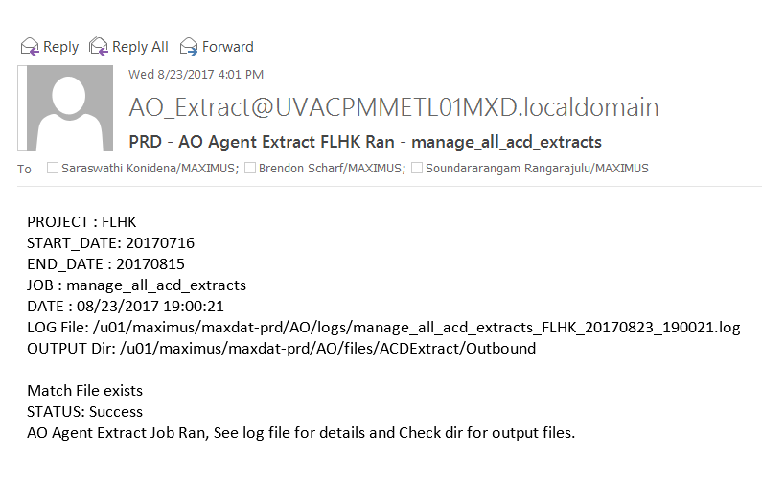

# Projects involved:

|  |  |  |
| --- | --- | --- |
| Project | ACD | Server |
| FLHK | Cisco | Cisco Enterprise |
| TXEC | Cisco | TX Server |
| FHCO | Avaya | Folsom |
| FOLSOM | Avaya | Folsom |
| GLENDALE | Cisco | Cisco Enterprise |
| MDHIX | Cisco | Cisco Enterprise |
| MIEB | Cisco | Cisco Enterprise |
| RHCO | Cisco | Cisco Enterprise |

# Tasks:

Step 1: Input file generation job runs in both the servers on 16th morning. A successful run would send email to the concerned. Go to the Input file directory, get the Files from there, compare the data and size of the files are consistent with last months files and do not vary too much in size. Email the files to Eric Stewart/Erin Lacey King/Devin/Valerio/Gary/Ann J Russo.

Input file directory is

Cisco Enterprise Server: /u01/maximus/maxdat-prd/AO/files/Agentmap/Outbound

TX Server: <http://txebreporting.oracleoutsourcing.com/AO_files/Agentmap/Outbound>

Step 2: Receive Match files in a few days from Eric for each of the Projects. For Cisco Server, place the file in the Match file directory. For TX, create a jira ticket requesting DBA Rahul Chennareddy to place the Match file in appropriate dir.

Cisco Enterprise CC: /u01/maximus/maxdat-prd/AO/files/Agentmap/Inbound

TX Server: <http://txebreporting.oracleoutsourcing.com/AO_files/Agentmap/Inbound>

Step 3: The Extract job runs hourly from 16th to 25th of each month. It looks if there is a Match file in Inbound folder. If it finds one, it runs the Extract job. Extract files are generated in the Extract_outbound folder. Check for file size, check the log directory for the job run log, check for number of rows is more or less consistent with last months extract file. Send the Extract file to same persons as in Step 1.

Cisco Enterprise Server: /u01/maximus/maxdat-prd/AO/files/ACDExtract/Outbound

TX Server: <http://txebreporting.oracleoutsourcing.com/AO_files/AOExtract/Outbound>

## Additional Tasks:

* Check Logs directory for “Nomatch” file. If it exists for any project, it means monthly ACD data exists for agents but the Match file which was provided did not have that Agents match information.
* Check Logs directory for run log of job to make sure it executed without any errors.
* If Terminated Clients disappearing issue is there, run additional manual steps to get AO info for terminated clients.